Giraffe News July 2019
Coming Events

July 26 – Parent’s Day Breakfast
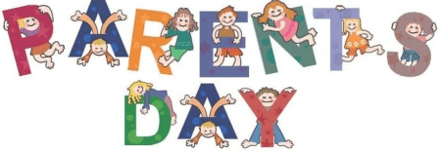
July Birthdays  11 – Yusuf S.  20 – Emma A.  26 – Gabby H.  28 - Genesis D. |  | Parent Corner  8 Life-Saving Water Safety Rules Every Parent Needs to Know  1: Never take your eyes off your child when she's in or around the water.  2: Ignore your phone.  3: Don’t rely on water wings, inflatable toys, floating loungers, or pool noodles.  4: Sign up your child for swimming lessons.  5: Make older kids buddy up.  6: When there's a crowd, put a parent on lifeguard duty.  7: Teach your child the rules.  8: Learn CPR.

Joke of the Month  What did the American Flag say to the other Flag?  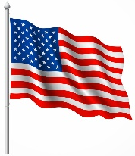 Nothing, it just waved. | Follow us on  &
We appreciate your testimonials on Google & our Website

